Task 8.2D
Question 1
Data Collection
Real estate data was manually collected from RealEstate.com by filtering for the latest sold properties for three suburbs with contrasting characteristics. The first chosen suburb was Hawthorn, chosen due to its proximity to the CBD (~5km), high density of apartments in the area, and relatively moderate pricing. This provided a sample of urban, mixed types of real estate listings with a focus on apartment living.
The second suburb was Camberwell, chosen for its mid-range location (~12km from the CBD) and mix of family homes and townhouses, with higher average prices. This emphasises larger residential properties over apartments.
The final suburb chosen was Ringwood North, selected as an outer-suburban area (~25km from the CBD) mostly dominated by standalone housing and more affordable pricing compared to Camberwell. This provided a sample of traditional family housing outside of the metropolitan area.
55 of the most recent sold properties were collected, building a dataset of 165 total samples. For each property, its address (for reference), property type, number of bedrooms, number of bathrooms, number of parking spaces, if there’s space for a study, sold data, land/building size, and sold price were collected. This provided a foundational dataset that captures key characteristics that might influence housing prices, without being overly complex or over-engineered
Question 2
Data Processing
The above dataset was loaded into a DataFrame. From here, the address column was dropped due to it only being a reference column unsuited for regression analysis. General cleaning was then performed, with the column names being standardised, the sold price and housing/land size columns being reformatted and made numeric, and the sold date column being formatted as datetime.
Missingness analysis was performed on the dataset. The results showed that only the land/building size column contained missing values, missing a total of 81 (49.3%), accounting for nearly half of the entries. Unfortunately, not all real estate listings on RealEstate.com published the land/building size, especially for apartments in the Hawthorn area. Due the large proportion of missing values, and the observation that some size listings include both land and dwelling while others did not, housing/land size was dropped from the dataset to avoid negative impacts on model development.
Feature Engineering
To improve the dataset further and capture some potential non-linear relationships, three relevant features were engineered. The first was total number of rooms, built from sum the number of bathrooms and number of bedrooms. Second was the bedroom to bathroom ration, built from dividing number of bedrooms by number of bathrooms. The last was parking spaces per bedroom, built from dividing number of parking spaces by number of bedrooms.
These features capture potential relationships between the other variables, as well as attractive to certain kinds of buyers. For example, a higher ratio of bedrooms to bathrooms may be more appealing for families or for shared dwelling. Additionally, the total number of rooms serves as a stand-in for property size.
Moreover, the study feature column was turned into a Boolean category representing whether the property has an included study area.
Data Exploration
Numerical Features:
To evaluate correlation between each numerical feature and the target sold price, as well as correlation between features, a heatmap was developed, shown in Figure 1.
Figure 1 – Correlation Heatmap
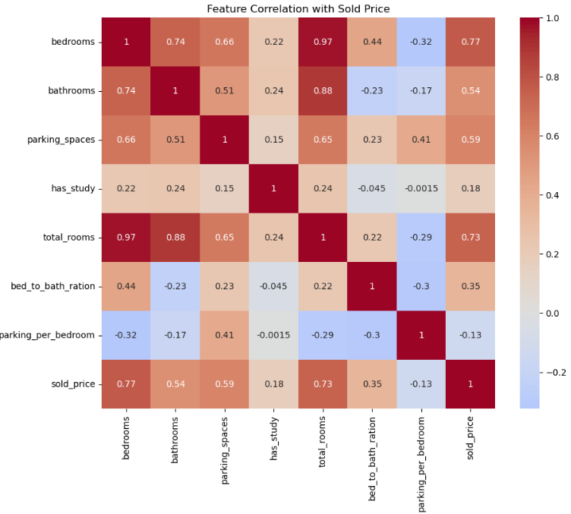
From Figure 1, sold price showed the strongest positive correlation with number of bedrooms (0.77) and total rooms (0.73), with more moderate positive correlations with number of bathrooms (0.54) and number of parking spaces (0.54). Whether the property has a study (0.18) and the parking per bedroom (-0.13) showed little correlation with sold price.
Between features, number of bedrooms and number of bathrooms had a high degree of correlation (0.74) indicating strong interaction between these two variables. This justifies the inclusion of the total rooms and bed to bath ratio features, as these will capture the relationship between bedrooms and bathrooms in a way that the regression models will better learn from.
The correlation between number of bedrooms and sold price, as well as number of bathrooms and sold price, are more closely evaluated in Figure 2 and Figure 3.
Figure 2 – Number of Bedrooms and Sold Price Correlation
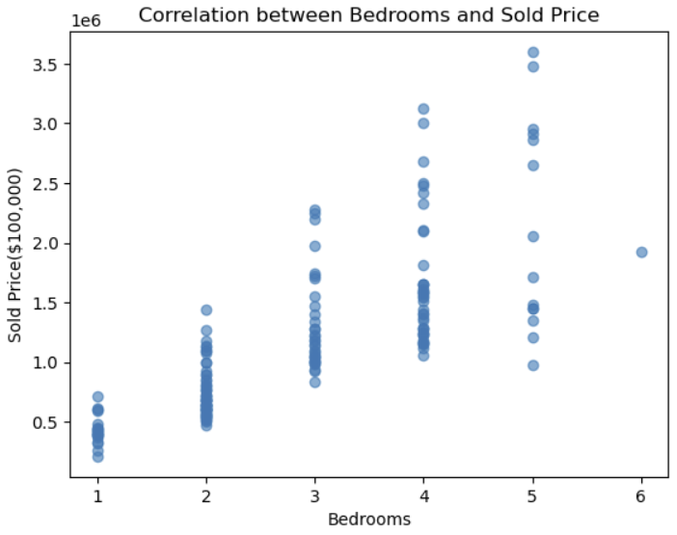
Figure 3 – Number of Bathrooms and Sold Price Correlation
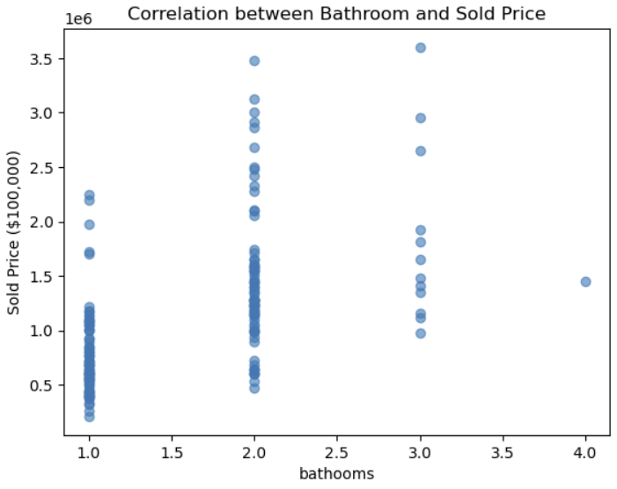
From Figure 2, the number of bedrooms in the dataset ranged between 1 and 6, while sold price ranged between $250,000 and ~$3,700,000. The scatterplot shows the clear positive correlation, with sold price increasing consistently with the number of bedrooms.
From Figure 3, the number of bathrooms is a smaller range, between 1 and 4. Further, a higher proportion of the properties had only 1 or 2 bathrooms, with very few have 3 or 4. Although less present here, here is still a clear positive correlation between number of bathrooms and sold price.
From both Figure 2 and Figure 3, there is the presence of an extreme value and possible outliers, with one property with 6 bedrooms and one property with 4 bathrooms.
Categorical Features:
To better understand the relationship between property type and the number of bedrooms, bathrooms, and parking spaces, a grouped bar chart was developed, and is presented in Figure 4.
Figure 4 – Bedrooms, Bathrooms, Parking Spaces, and Property Types
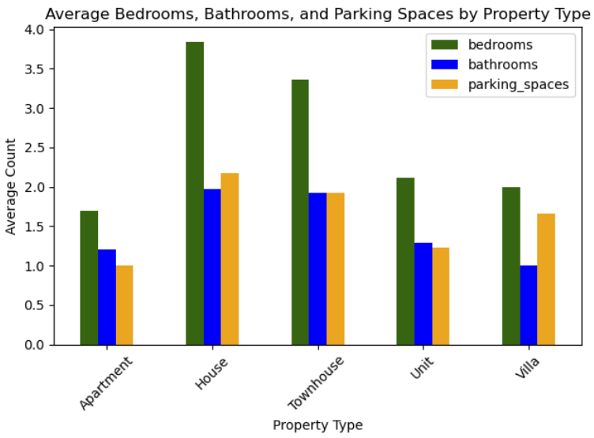
Houses and Townhouses had by far the highest average number of bedrooms, bathrooms, and parking spaces, while apartments had the least, reflecting the size expectations of each property type. Bedrooms experienced the most fluctuation in average number per property, ranging from ~1.75 (apartments) to ~3.7 (houses).
Figure 5 displays the sold price by property type.
Figure 5 – Sold Price by Property Type
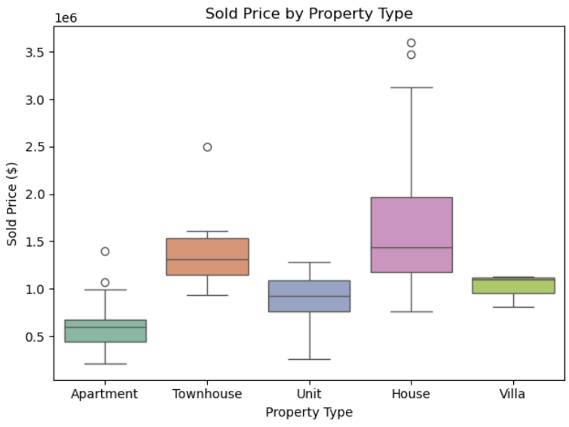
From Figure 4, houses had the highest median sold price (~$1.4 million, while also experiencing a larger range of prices. The house sold prices also showed a right skew. Apartments experienced the lowest median sold price (~$700,000) with a much smaller range of values. The sold price for each property type closely aligns with the number of bedrooms, bathroom, and parking spaces as seen in Figure 3, indicating that the number of rooms is a large predictor of sales price, while also showing a relationship with property type.
There are four possible outliers present within the property type data, 2 for houses, 2 for apartments, and 1 for townhouses which was the most significant. However, analysis of these extreme values reveal that they are genuine luxury properties, provided real information and valuable data. As such, they were left in for regression modelling.
Figure 6 – Sold Prices by Suburb
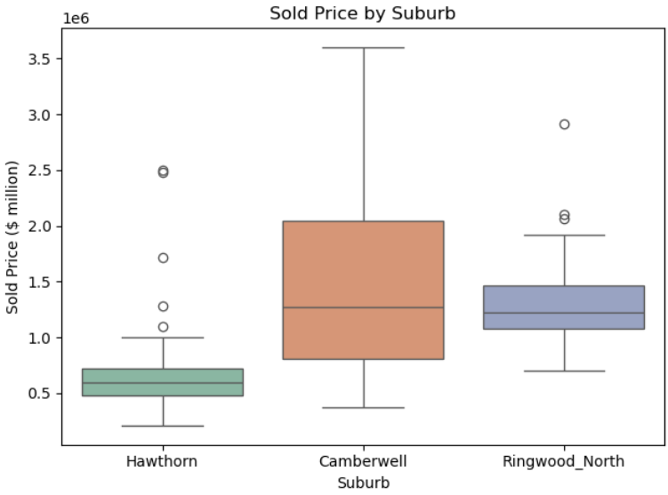
From Figure 6, Camberwell had the highest median sold price (~$1.3 million), while also having the largest price range. Hawthorn had the lowest median price (~$0.6 million) as well as the shortest price range. This indicates that suburb will be a strong predictor of property price, with Camberwell being a more luxurious suburb compared to Ringwood North and Hawthorn. Hawthorn and Ringwood North both had extreme values, however, further analysis revealed these to be genuine real estate sold prices, justifying their continue inclusion in the dataset.
Figure 7 – Sold Price Distribution
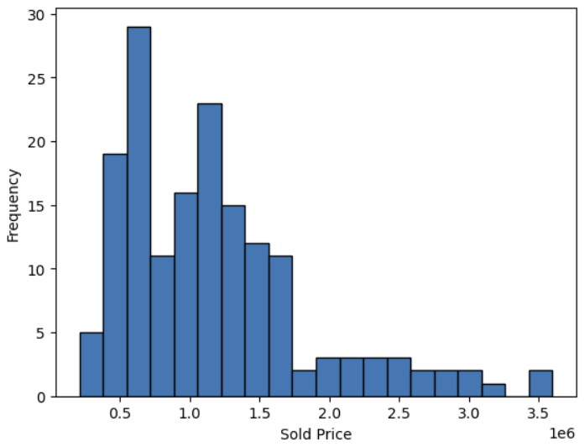
Overall sold prices for the full dataset showed a clear multimodal distribution with a positive skew. House prices mostly clustered around the $700,000 or $1,200,000 price points, with several luxury properties breaking the $2,000,000 barrier. The multimodal distribution likely reflects apartments and houses median respectively, as these were the most frequent property types in the dataset.
Market Trends over Time
Figure 8 shows the total properties sales per month for Hawthorn, Camberwell, and Ringwood North. As the dataset contains the 55 latest sold properties for each suburb, the starting dates are varied.
Figure 8 – Total Property Sales per Month by Suburb
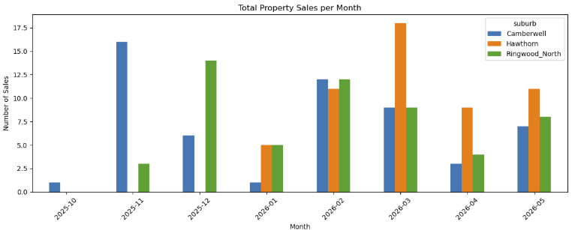
From Figure 8, Hawthorn had the most properties sold in 2026, with the most sales occurring in March. This may reflect the suburbs higher proportion of medium-density housing, with a high number of apartments sold at more affordable prices. Camberwell, being the most expensive suburb, had its last of the 55 sales occurring in October 2025, reflecting the higher prices and higher barrier to entry. The differences in monthly sales trends highlight market activity variation between the high-value and the more moderately priced suburbs within Melbourne.
Figure 9 – Sold Price Trends over Time by Suburb
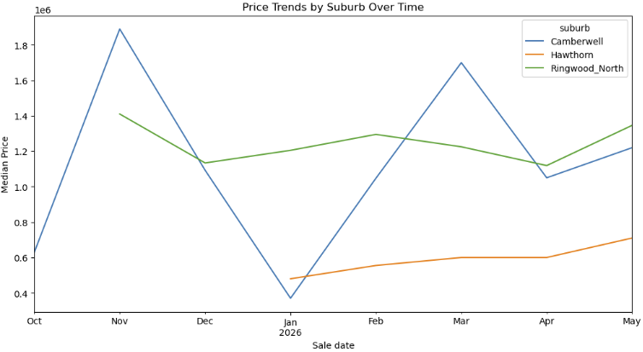
Figure 9 presents the median sold price for each month for each suburb. As expected, Hawthorn showed the lowest median prices, reflecting its comparatively high market activity and increased proportion of apartments, typically selling at lower price points. Camberwell showed the highest peaks in median sold price, but also significant dips caused by only apartments or units being sold during the slower January and October months. Ringwood North showed consistent median sales price from November 2025 to May 2026, suggesting a more consistent segment of the market with less variability in property type and pricing.
Data Preprocessing
To prepare the data for regression model training, the target variable sold price was separated from the rest of the data. Non-predictive temporal columns, including sold date, sale month, and sale week, were removed, as they are not suitable for inclusion in the regression models.
The data was split into 80% training 20% test sets. One-hot encoding was applied to the categorical variables to convert them into numerical format for regression modelling. Standardisation was applied to the numerical features to ensure all variables were on a comparable scale. This prevents feature with larger values from dominating during model training.

Question 3 – Model Development
To predict Melbourne housing prices, three regression models were developed. These were Ridge Regression, Random Forest Regressor, and Gradient Boosting Regressor. These three models were chosen in order to provide a strong comparison between linear approaches, ensemble bagging, and ensemble boosting. This will provide an evaluation of both simple linear correlations and complex non-linear relationships with the real estate dataset. Further, the use of bagging and boosting approaches will allow an exploration of the bias-variance trade-off when training and testing the models.
All models were trained on the same pre-processed features, with model performance evaluated using 5-fold cross-validation and on the test dataset.
Model Setup and Hyperparameter Tuning
Model 1 – Ridge Regression
Ridge Regression was chosen as a baseline linear model due to its simplicity. Ridge was selected over standard linear regression as the use of L2 regularisation penalises large coefficients and reduces overfitting, importantly in smaller datasets like the collected real estate data.
To find the best hyperparameters, the Ridge Regression model was tuned using Grid Search Cross Validation, specifically tests different levels of regularisation strength through the alpha value. For the grid search, negative mean squared error was chosen as the optimisation metric for a 5-fold cross-validation.
Model 2 – Random Forest Regressor
Random Forest was selected as a non-linear bagging ensemble model able to capture complex interactions between housing features. Random Forest works by building multiple decision trees using bootstrapped samples and averaging their predictions to make a final decision. This approach reduces variance in the model, potentially improving overall generalisation.
The same 5-fold cross-validation grid search with negative mean squared error was applied to find the best hyperparameters. For Random Forest, the number of trees in the forest, the max depth of each decision tree, and the minimal number of samples required to split a node were all tuned during the grid search. Tuning these hyperparameters helps to control tree complexity, finding the best way to reduce variance while maintaining predictive power.
Model 3 – Gradient Boosting Regressor
Gradient Boosting was chosen as a more complex boosting ensemble model due to its ability to capture complex non-linear relationships between housing variables, and to provide a comparison to the bagging approach. The algorithm works by sequentially building additive models, where each decision tree is trained to correct the residual errors of the previous trees. This allows a progressive improvement of the model’s predictions while keeping bias low.
However, Gradient Boosting can be prone to overfitting. To address this, 5-fold cross-validation grid search was once again applied to find the best hyperparameters to balance learning speed with generalisability and to control overfitting. The number of trees (boosting stages), the learning rate, and the max depth of each tree were tuned during the grid search.
Model Training and Training Performance Evaluation
Model 1 – Ridge Regression
From the Grid Search Cross Validation with five folds, the best performing Ridge Regression model had a low alpha value (regularisation strength) of 0.1, indicating that weak regularisation was the best fit for the real estate dataset.
5-fold cross validation on the training dataset was used to evaluate the best Ridge Regression model’s performance on the training dataset. The results are show in Table 1.
Table 1 – Ridge Regression CV Training Performance
Fold | RMSE
1 | 233,478
2 | 394,180
3 | 274,467
4 | 304,721
5 | 256,092
MEAN | 292,588

Cross-validation results show a significant variation in RMSE across folds, ranging from 233,478 to 394,180, with a mean RMSE of 292,588. This indicates that model performance was highly dependent on the samples contained in the training-validation split, a possible result of the small total sample size (165) with large real estate sold prices (~$200,000 to ~$3,700,000).
Model 2 – Random Forest Regressor
From the Grid Search Cross Validation with five folds, the best performing Random Forest Regressor model had 50 estimators, a maximum depth of 20, and a minimum samples split of 2. These hyperparameters suggest that a relatively deep tree with smaller ensemble size provided the greatest balance between bias and variance management for the small real estate dataset.
5-fold cross validation on the training dataset was used to evaluate the best Random Forest model’s performance on the training dataset. The results are show in Table 2.
Table 2 – Random Forest CV Training Performance
Fold | RMSE
1 | 210,253
2 | 381,071
3 | 340,526
4 | 305,556
5 | 206,156
MEAN | 288,712

The cross-validation results show strong variation in RMSE across folds, ranging from 206,156 to 381,071, with a mean RMSE of 288,712. Similar to Ridge Regression, model performance was sensitive to the specific training-validation split, suggesting high variability in the dataset and limitations due to the small sample size (165).
Compared to Ridge Regression, Random Forest achieved a slightly lower mean RMSE, indicating a slight improvement in predictive performance in the training set. This suggests that capturing non-linear relationships between features provided some benefit for modelling real estate prices. The reduction in variance through ensemble averaging provided marginal improvements on model performance.
Model 3 – Gradient Boosting Regressor
From the Grid Search Cross Validation with five folds, the best performing Gradient Boosting model had 200 estimators, a learning rate of 0.1, and a shallow maximum depth of 3. This configuration indicates that a shallow tree with a higher number of boosting iterations was best for reducing bias, preventing overfitting, and balancing with predictive power.
5-fold cross validation on the training dataset was used to evaluate the best Gradient Boosting model’s performance on the training dataset. The results are show in Table 3.
Table 3 – Gradient Boosting CV Training Performance
Fold | RMSE
1 | 225,449
2 | 354,472
3 | 335,155
4 | 324,949
5 | 208,647
MEAN | 289,735

Once again, cross-validation results show high variation in RMSE across folds, ranging from 208,647 to 354,472, with a mean RMSE of 289,735. These results confirm that high variation in model performance across folds was not a limitation of the model algorithms, but rather a limitation of the small dataset with a wide sold price range.
Compared to both Ridge Regression (292,599 RMSE) and Random Forest (288,712 RMSE), Gradient Boosting achieved comparable performance. However, the model performed slightly worse than Random Forest and slightly better than Ridge Regression. This suggests that boosting and reducing bias only provided a marginal improvement for this dataset and was outperformed by bagging techniques. Further, the higher performance of bagging suggests that high variance in the dataset played a more significant role in weakening performance compared to bias.
Model Evaluation on the Test Dataset
To fully determine the best performing model on unseen data, performance for all three models were evaluated on the held-out test dataset (20% of the data). Performance was measured using MAE, RMSE, and R² to provide a comprehensive assessment. The final model test performance results are shown in Table 4.
Table 4 – Model Performance on Test Set
Model | MAE | RMSE | R²
Ridge Regression | 199,413 | 281,680 | 0.833
Random Forest | 214,377 | 286,039 | 0.828
Gradient Boosting | 206,389 | 284,488 | 0.830

The results show that all three models achieved mostly similar performance, with only minor differences across the evaluation metrics. Ridge Regression achieved the lowest RMSE and MAE, along with the highest R², being the best performing model on the test dataset. Gradient Boosting performed only slightly worse than Ridge Regression, suggesting that it was able to capture useful non-linear relationships without significant improvement over linear correlations. Random Forest performed the worst of the three across all metrics, indicates that bagging produced poorer generalisations for the real estate dataset.
The small performance gaps between the models demonstrates that the data structure and small sample size puts limitations on the benefits that more complex non-linear models generally provide. Further, the inclusion of the total rooms and bedrooms per bathrooms ratio features could have been effective in capturing non-linear relationships between the two features most highly correlated with sold price, providing an advantage to the simpler Ridge Regression.
Interestingly, Ridge Regression performed the best on the test set, while Random Forest outperformed on the training set during cross validation. This is likely due to the more complex non-linear Random Forest approach very slightly overfitting to the training data, reducing error in each fold, and providing a slightly optimistic cross-validation performance. Ridge Regression’s L2 regularisation constraint penalises large coefficient values, reducing model complexity.
For the small real estate dataset, the simpler Ridge Regression model outperformed bagging and boosting approaches. However, with such similar performance across the three models, any of them could provide moderate to strong predictive performance on new unseen data.
Question 4
Feature Importance Evaluation
To better understand the modelled relationships between the features and the sold price target, feature importance evaluation was performed. First, the weighted coefficients for the Ridge Regression model were extracted, providing an overview of which features had the strongest influence on sold price for the linear model. Next, the model-specific feature importance methods for the tree-based random forest and gradient boosting models were used to determine the most influential features for these models. Finally, SHAP values were calculated for all three models.
Ridge Regression – Weight Coefficients
Table 5 – Ridge Regression Feature Coefficients
Feature | Coefficient
suburb_ringwood_north | -855,093
property_type_house | 767,561
bedrooms | 508,694
bathrooms | -324,925
property_type_Townhouse | 312,411
property_type_unit | 292,316
total_rooms | 234,419

For the Ridge Regression model, the coefficient show that property type house and the number of bedrooms were the two most important features increasing sold price. This is expected, as larger properties (houses) with more sleeping areas are the largest drivers of price, as well as reflecting the high correlation between sold price and bedrooms seen in the exploratory data analysis. Ringwood North was the most important feature that decreased sold price, likely meaning that the model learnt the more expensive Camberwell costs as the baseline in the dataset. Further, total rooms being seen an relatively important justifies its inclusion, possibly capture a non-linear trend between bathrooms and bedrooms.
Table 6 – Random Forest Feature Importance
Feature | Importance
Bedrooms | 0.488
Total rooms | 0.149
Suburb_ringwood_north | 0.140
Parking_Spaces | 0.059
Property_type_House | 0.059
Parking_Per_Bedroom | 0.032
Has_Study | 0.017
The Random Forest feature importance metrics provide a measure of how much each feature helped to reduce impurity (Gini) in across all trees. From Tabe 6, Bedrooms was by orders of magnitude the most influential predictor of housing price, accounting for 48.8% of the model’s decision-making. This is followed by total rooms of the Ringwood North suburb, which both contributed meaningful but to a much lesser degree. All other features had importance values below 0.1, suggesting little overall impact. These results demonstrate that the Random Forest model learnt the number of bedrooms as the best, most impactful, and most consistent feature for reducing impurity in the trees and predicting housing prices.
Table 7 – Gradient Boosting Feature Importance
Feature | Importance
Bedrooms | 0.323
Total rooms | 0.239
Suburb_ringwood_north | 0.203
proprety_type_house | 0.083
parking spaces | 0.059
Parking_Per_Bedroom | 0.024
bed_to_bath_ratio | 0.016

The Gradient Boosting feature importance results largely agree with Random Forest of what feature were the most influential (number of bedrooms, total rooms, and the Ringwood Suburb). However, Gradient Boosting assigned less dominance to bedrooms and relatively more importance to total rooms and Ringwood North compared to Random Forest, producing a more balance distribution of feature importance. The ability for Gradient Boosting to sequentially builds trees while correcting the errors of previous iterations likely allowed the model to better distribute predictive weight through multiple features collectively reducing residual error.
Figure 10 – SHAP Values for Ridge Regression
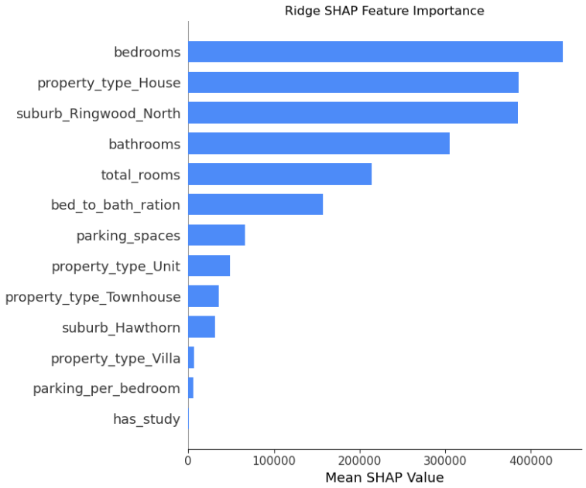

Figure 11 – SHAP Values for Random Forest
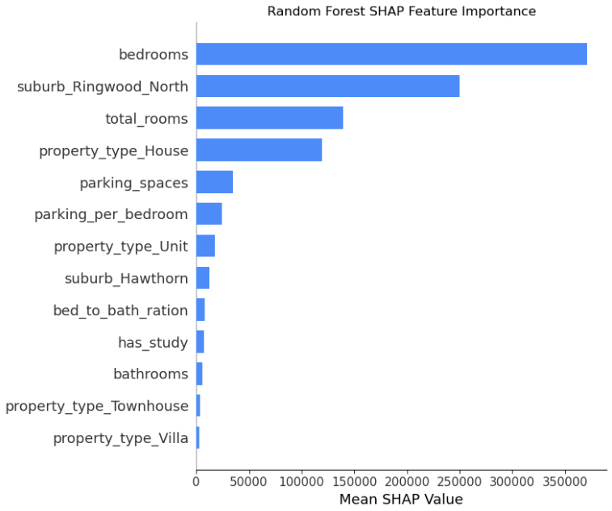
Figure 12 – SHAP Values for Gradient Boosting
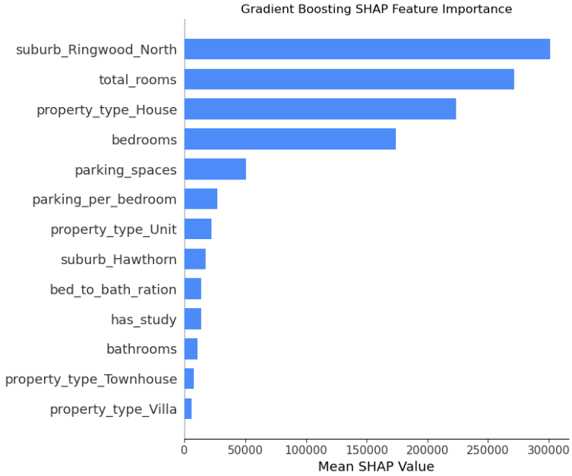
SHAP Values provide further evaluation of the most important features for each model. Figure 10-12 present a high degree of agreement between all three models on the overall most influential feature on total housing prices. Random Forest and Gradient Boosting, both non-linear models, agree on the top 4 most important features being bedrooms, total rooms, Ringwood North, and the house property type. Gradient Boosting produced a more balance distribution of feature importance, while Random Forest was dominated by bedrooms. The SHAP values closely matched the model-specific feature importance values, providing additional evidence bedrooms, total rooms, and property types as the most influential features
For Ridge Regression, the best performing model on the test dataset, bedrooms, house property type, Ringwood North, and bathrooms had the highest SHAP values, followed by total rooms. The presence of total rooms as a strong predictive feature across all three models indicates that feature engineering for valuable for regression model performance.
Question 5
Deployment:
The final Ridge model, chosen due to its superior performance on the test dataset, was deployed in a simple web application demo using streamlit. Examples of the working demo with user input and model output are shown in Figures 13 and 14.
Figure 13
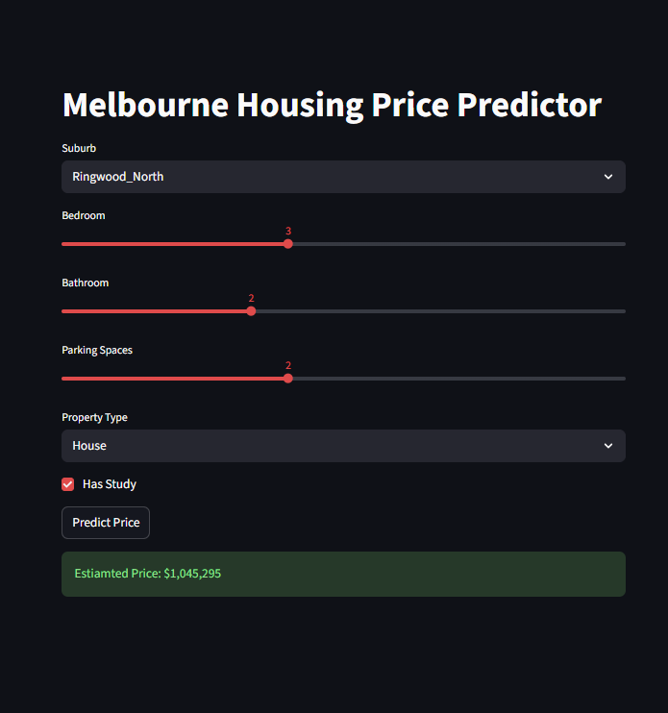
Figure 14
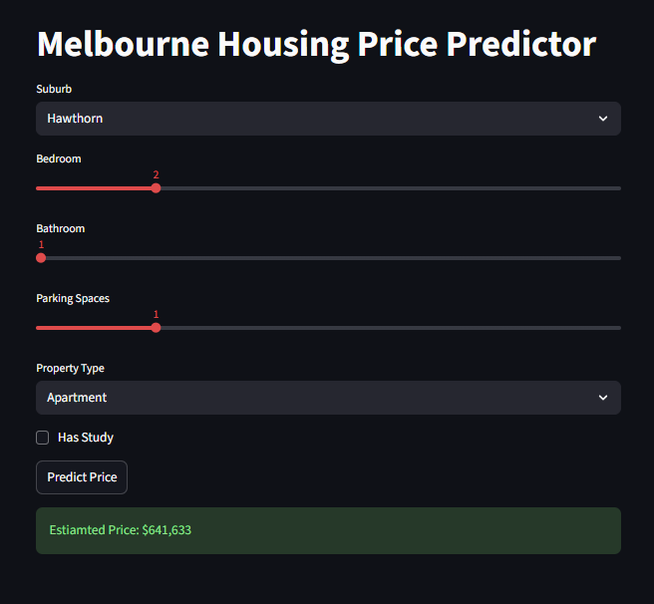
The demo allows users to enter key features using drop downs and sliders, including suburb, number of bedrooms, number of bathrooms, number of parking space, property type, and room for a study. On the backend, the demo takes the inputs, calculates the engineered features of total rooms, bedroom to bathroom ratio, and parking spaces per bedroom. Then, the model is called from the loaded pkl final along with the preprocessor scaling. This is done to ensure that the user input is scaled in the same manner that the model was trained on. The model is then used to make predictions on the user input, outputting the predicted sales price.

Question 6
LLM Prediction Comparison – Claude
To compare the best performing model on test data, Ridge Regression, with the predictions of a large language model, a new K-fold with 5 total folds was created, with the first fold extracted for analysis. Claude was selected as the LLM due to leading performance in coding and increasingly common use in industry, The follow prompts were used to produce predictions from Claude:
“I am going to provide you with a csv file containing property data along with the target variable sold price. Have a look at the csv, learn the pattern. I will then provide a csv with data without sold prices. When this is provided, make predictions on the new data. Is this understood?”
“Here is the data. Make predictions and include them in a csv.”
The data provided was from the extracted first fold. Claude’s predictions were provided in a CSV, which was loaded into the Jupyter notebook. RMSE, MAE, and R² were calculated on the validation dataset. The Ridge Regression model was used to make predictions on the same folds. The results are provided in Table 8.
Table 8 – LLM and Ridge Regression MAE, RMSE, and R²
Model | MAE | RMSE | R²
Claude | 227,496 | 316,572 | 0.532
Ridge regression | 138,086 | 206,961 | 0.800

The Ridge Regression model significantly outperformed Claude.ai in predicting housing prices on unseen data, with R² of 0.8 compared to 0.532, explaining a much larger proportion of the variance in housing prices. The far lower MAE and RMSE, indicating more accurate and consistent predictions.
The results of these experiments suggest that while Claude.ai was capable of capturing general patterns in the data, it lacked the optimisation and tuning of a trained statistical model. Ridge Regression provided more reliable and accurate housing price predictions, supporting the idea that task-specific machine learning models are superior to general-purpose LLMs for specific regression tasks.

